# Lab 1 PPP WAN Connection

Fill in the IP address table below with the IP subnetting scheme you made for the AT4 Part 3 session 7. VLAN 90 Server is to contain all the servers providing services to the PCs from all the departments, including Domain Controller (DC), DNS, DHCP, Network Monitoring Server (NMS), and the web server (www). DNS service is to be provided by the Domain Controller which means DC and DNS are using the same physical server.

Please assign the first available ip of each subnet as the default gateway for each vlan. Assign the second available ip of each subnet to the server. The servers in VLAN 90 can be assigned with any IPs within the subnet except the first available IP reserved for the default gateway. Assign the 11th available ip of each subnet to the PC.

| VLAN ID | VLAN NAME | HOST REQUIREMENTS | Network Address/Prefix | Default Gateway |
| --- | --- | --- | --- | --- |
| 20 | CS | 40 | 192.168.20.0/27 | 192.168.20.1 |
| 30 | Marketing | 40 | 192.168.30.0/27 | 192.168.30.1 |
| 90 | Server | 5 | 192.168.90.0/27 | 192.168.90.1 |

| VLAN ID | Host Name | IP Address/Prefix | Default Gateway |
| --- | --- | --- | --- |
| 20 | CS-FS | 192.168.20.3 | 192.168.20.1 |
| 20 | CS-PC-1 | 192.168.20.2 | 192.168.20.1 |
| 30 | Marketing-FS | 192.168.30.3 | 192.168.30.1 |
| 30 | Marketing-PC-1 | 192.168.30.2 | 192.168.230.1 |
| 90 | www | 192.168.90.3 | 192.168.20.1 |
| 90 | DC | 192.168.90.2 | 192.168.90.1 |

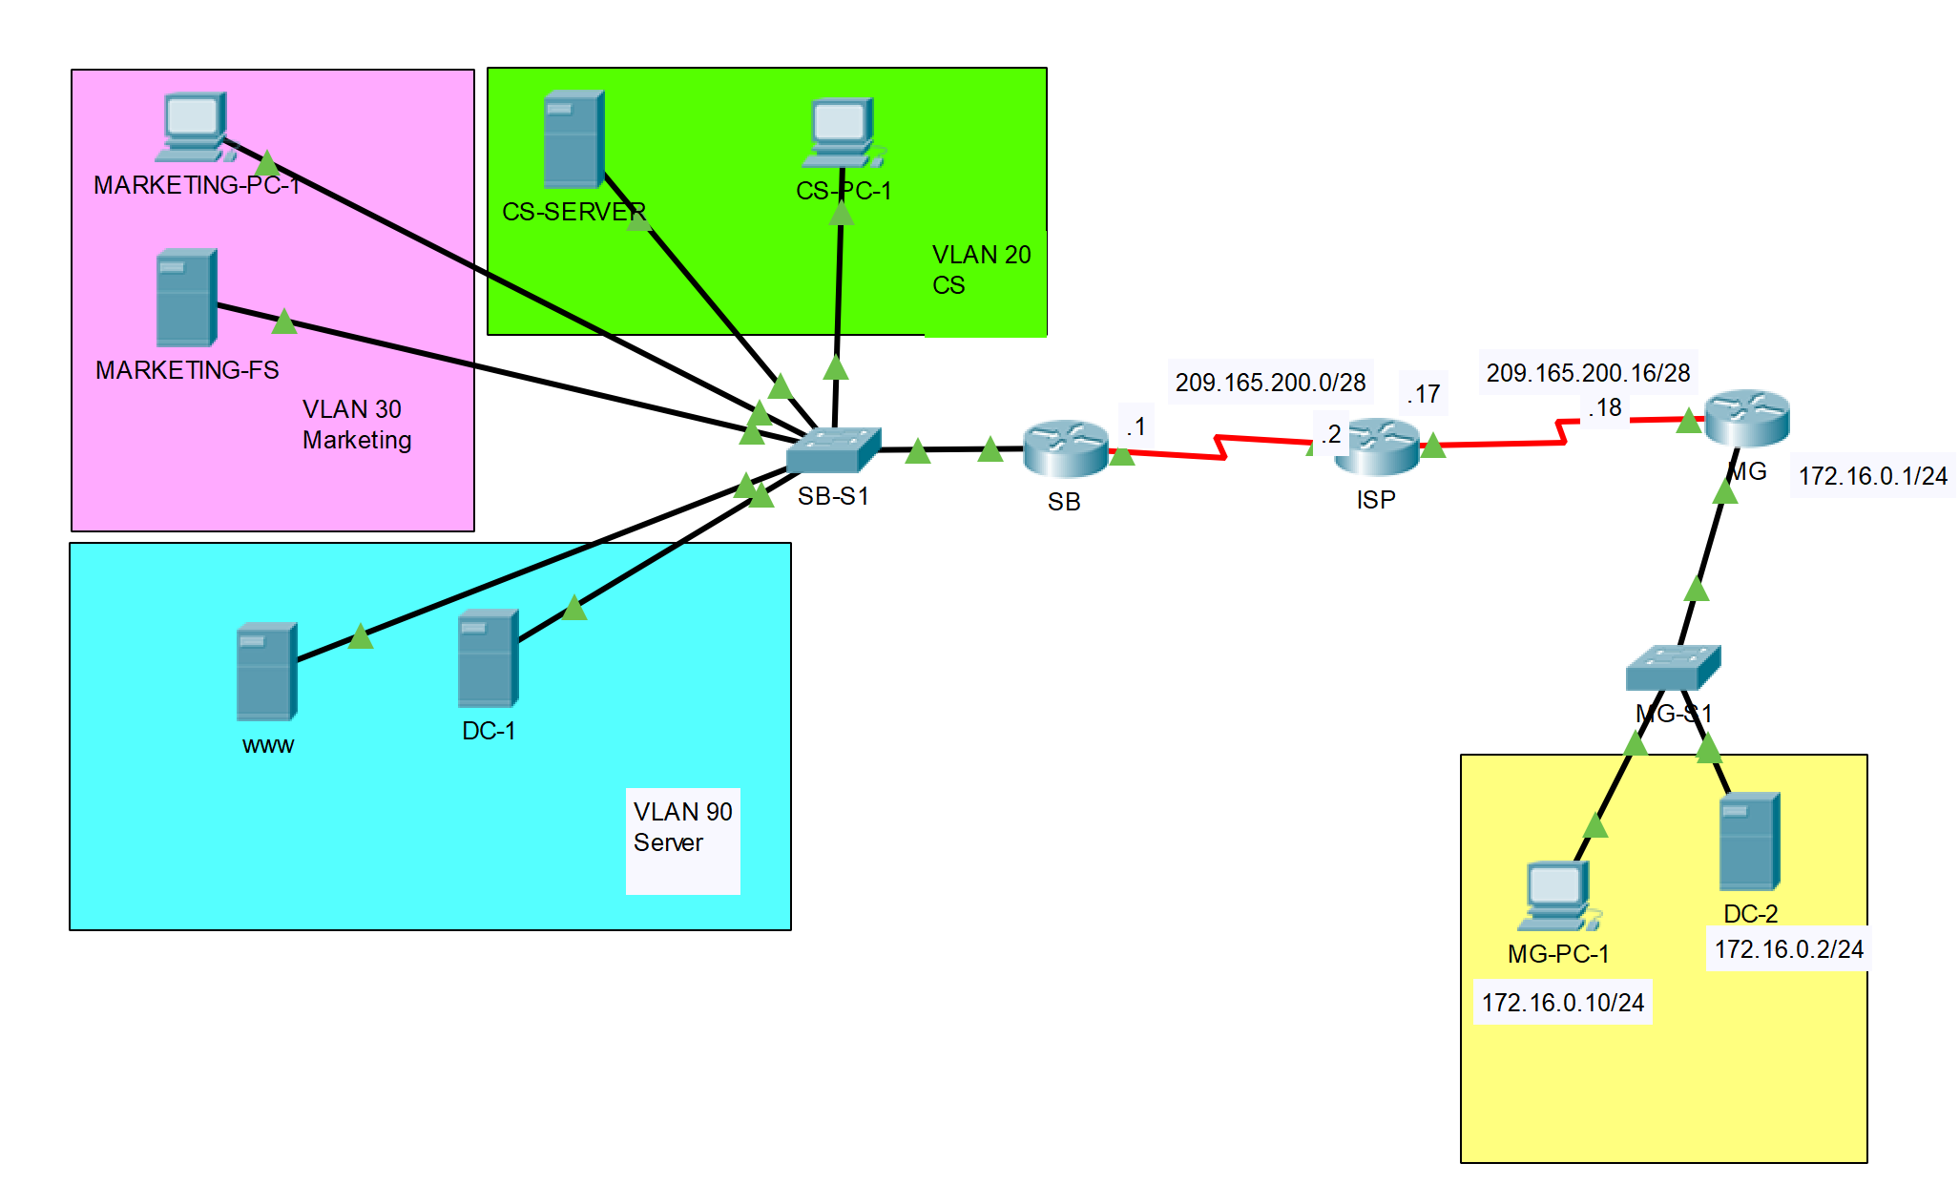

## Part 1: Cable the network and configure the devices IP address

**Step 1**. Cable the network as the topology above.

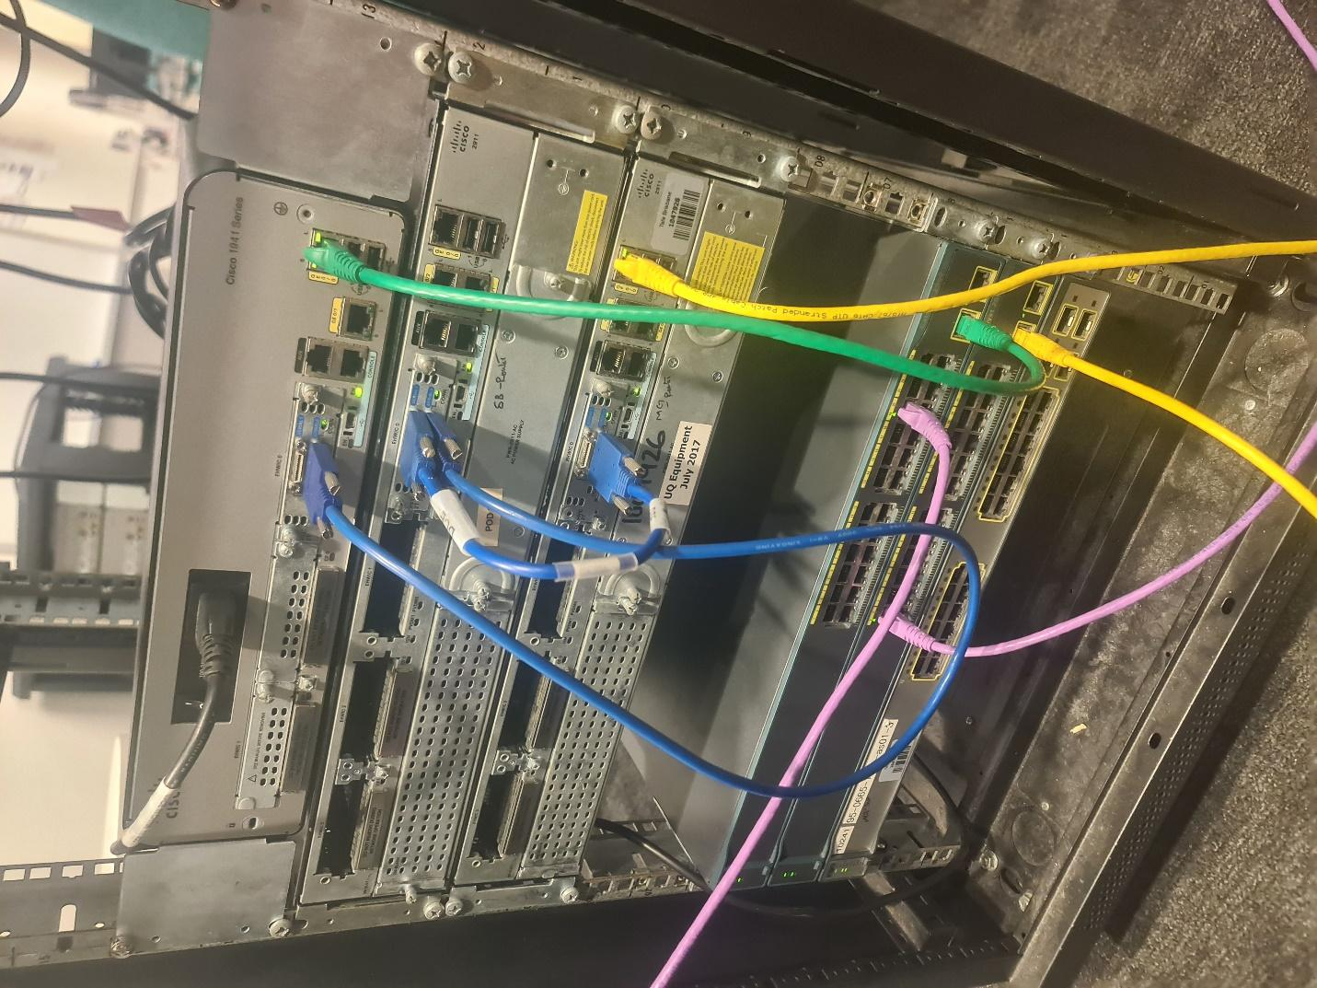

**Note**: In each subnet, the PC and the Server can be running as VMs on a same physical host.

**Step 2**. Configure the SB Router’s LAN interface G0/0 with router-on-a-stick configuration to cater for three VLANs at the same time. Assign the subinterfaces with IP address according to the aforementioned ip address table.

!###Configuring Router SB###!

conf t

hostname SB

!###Configuring G0/0 interface to up state###!

int g0/0

no shut

!### Configuring virtual routing interface for each Vlan###!

!##########################VLAN20##########################!

!####################VLAN 20 Has 40 PCs####################!

int g0/0.20

encapsulation dot1q 20

ip address 192.168.20.1 255.255.255.224

exit

!##########################VLAN20##########################!

!####################VLAN 30 Has 40 PCs####################!

int g0/0.30

encapsulation dot1q 30

ip address 192.168.30.1 255.255.255.224

exit

!##########################VLAN20##########################!

!####################VLAN 90 Has 5 PCs#####################!

int g0/0.90

encapsulation dot1q 90

ip address 192.168.90.1 255.255.255.248

exit

!###Showing Route table for confirmation###!

sh ip route

!##########################################################!

!###Showing ip interfaces configuration####!

sh ip int br

!###Part 1: Cable the network and configure the devices IP address!

!###STEP 2###!

!###Successfully completed!

**Step 3**. Configure VLANs and trunk interface on SB-S1.

When step 3 is finished, pings from any end devices from any VLANs should be able to reach the other end devices in the other VLANs within the SB router LAN side.

!###Configuring the hostname of SB-S1###!

en

conf t

hostname SB-S1

!### Initializing G0/1 - Goes to SB###!

int g0/1

switchport mode trunk

no shut

exit

!###Initializing Vlans###!

!###Initializing CS VLAN###!

int vlan 20

exit

!###Initializing Marketing VLAN###!

int vlan 30

exit

!###Initializing Server VLAN###!

int vlan 90

exit

!###Naming Vlans###!

!###Naming vlan 20###!

vlan 20

name CS

!###Naming vlan 30###!

vlan 30

name Marketing

!###Naming vlan 90###!

vlan 90

name Server

!###Configuring port ranges to co-incide with VLAN ranges###!

!###Configuring VLAN 20###!

int range fastEthernet0/1-8

description CS

switchport mode access

switchport access vlan 20

no shut

exit

!###Configuring VLAN 30###!

int range fastEthernet0/9-17

description Marketing

switchport mode access

switchport access vlan 30

no shut

exit

!###Configuring VLAN 90###!

int range fastEthernet0/18-24

description Server

switchport mode access

switchport access vlan 90

no shut

exit

**Step 4**. Configure the IP address on SB Router’s WAN interface, ISP router, MG Router, DC-2, and MG-PC-1 as described in the table below.

| SB | ISP | MG |
| --- | --- | --- |
| !### Step 4 Commands ###!  !### Configuring SB WAN interface###!  en  conf t  int s0/0/0  ip address 209.165.200.1 255.255.255.240  no shut  exit | !### Step 4 Commands ###!  !### Configuring ISP WAN interface###!  en  conf t  !### Configuring ISP -> SB interface###!  int s0/0/0  ip address 209.165.200.2 255.255.255.240  no shut  exit  !### Configuring ISP -> MG interface###!  int s0/0/1  ip address 209.165.200.17 255.255.255.240  no shut  exit | !### Step 4 Commands ###!  !### Configuring MG WAN interface###!  en  conf t  int s0/0/0  ip address 209.165.200.18 255.255.255.240  no shut  exit  !### Configuring MG LAN interface###!  int g0/0  ip address 172.16.0.1 255.255.255.0  no shut  exit |

| Device | Interface | IP Address/Prefix | Default Gateway |
| --- | --- | --- | --- |
| SB | S0/0/0 | 209.165.200.1/28 |  |
| ISP | S0/0/0 | 209.165.200.2/28 |  |
|  | S0/0/1 | 209.165.200.17/28 |  |
| MG | S0/0/1 | 209.165.200.18/28 |  |
|  | G0/1 | 172.16.0.1/24 |  |
| MG-PC-1 | Fastether port | 172.16.0.10/24 | 172.16.0.1/24 |
| DC-2 | Fastether port | 172.16.0.2/24 | 172.16.0.1/24 |

## Part 2: Configure PPP between the SB Router and the ISP Router

1. Display the serial interface’s encapsulation.

On the SB Router and ISP, issues **show interface serial** *interface-id* to display the current serial encapsulation. For example:

SB# **show interface s0/0/0**

**en**

**conf t**

**do sh int s0/0/0**

**!###HDLC is default serial encapsulation###!**

**int s0/0/0**

**encapsulation ppp**

**no shut**

**exit**

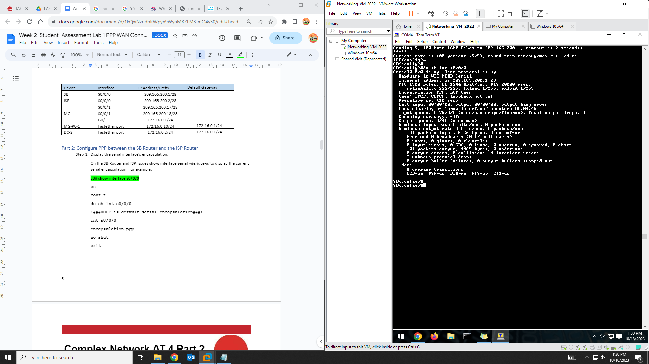

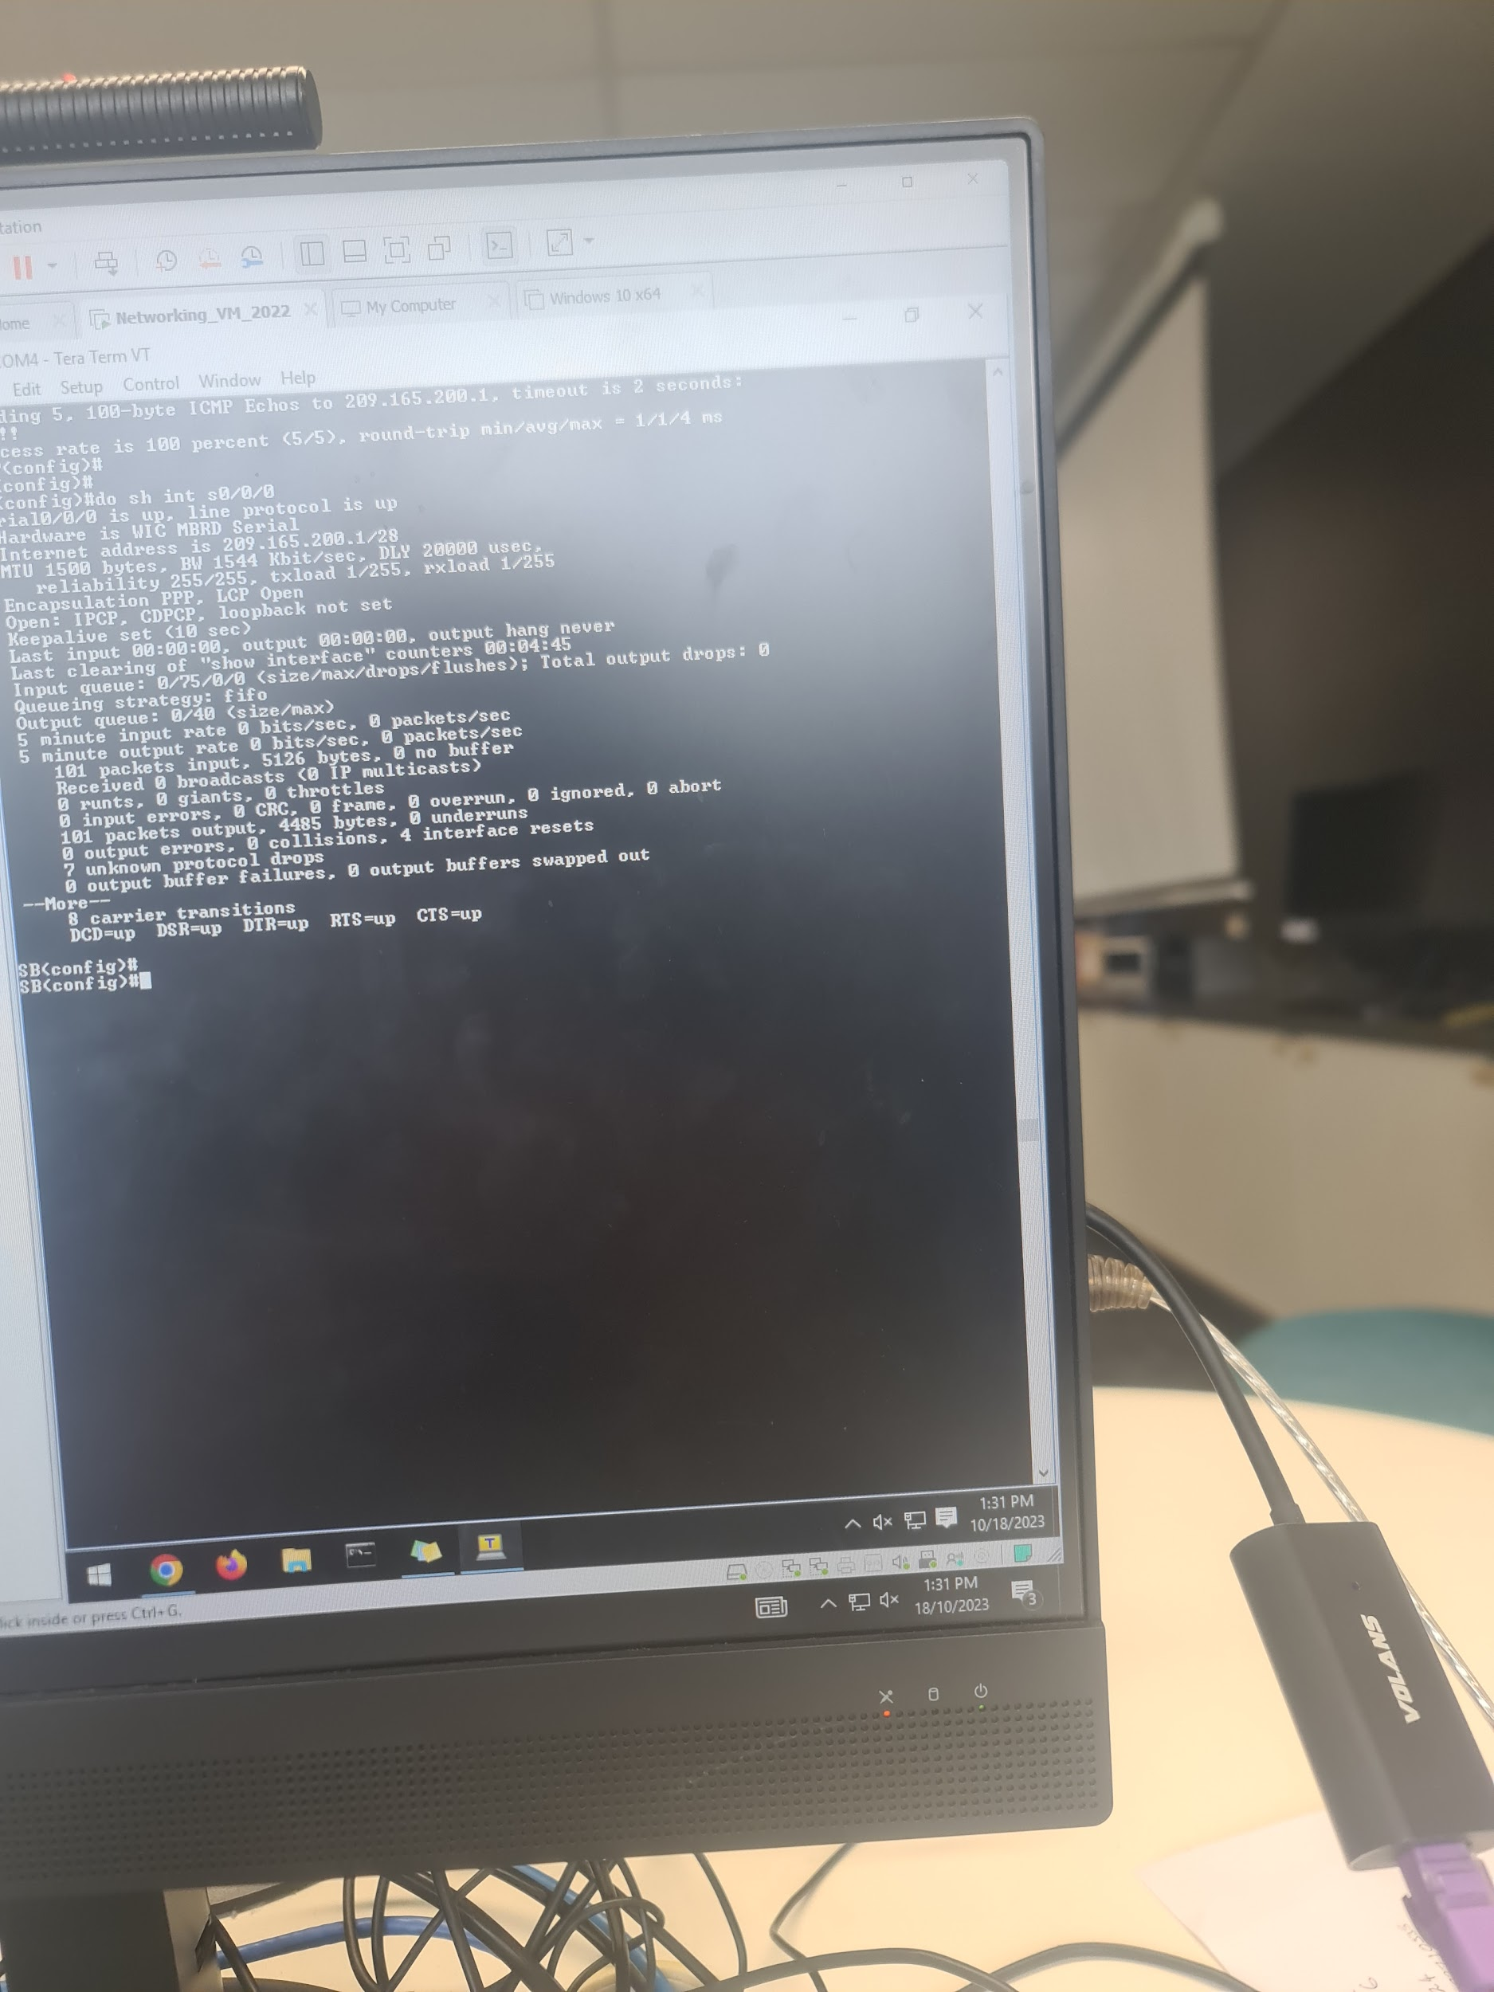

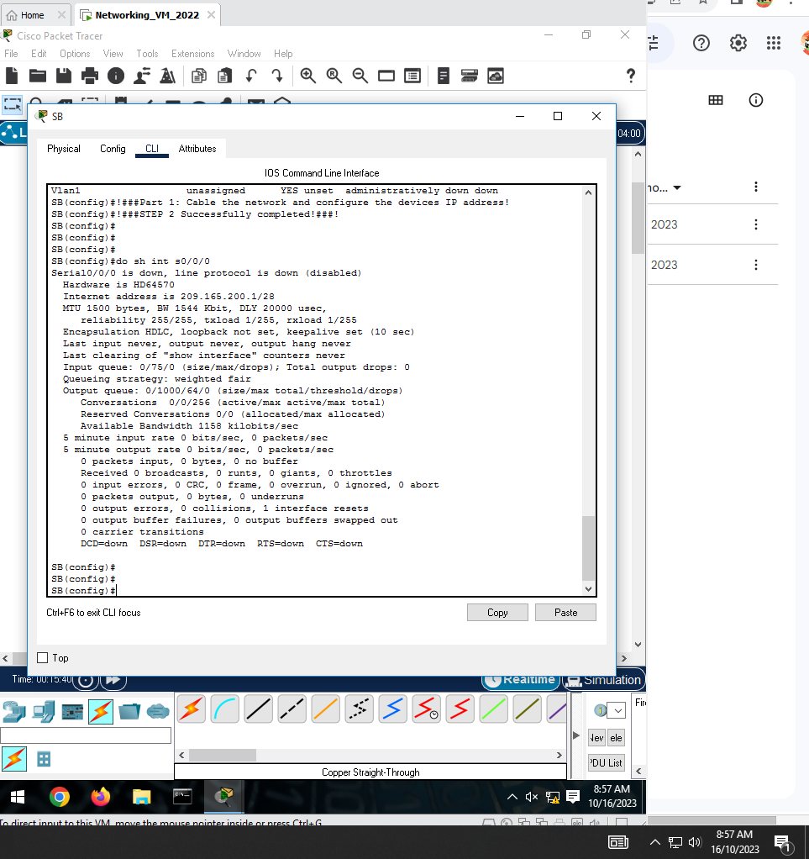

You will find the default serial encapsulation for a Cisco router is HDLC.

1. Change the serial encapsulation to PPP for the link between the SB Router and the ISP router.

| SB | ISP |
| --- | --- |
| en  conf t  !### Create credentials for other host (ISP) for PPP###!  username ISP password cisco  !### Change PPP to CHAP for SB Router###!  !#############################################!  !### Configuring PPP on s0/0/0###!  int s0/0/0  encapsulation ppp  ip address 209.165.200.1  no shut  exit | en  conf t  !### Create credentials for other host (SB) for PPP###!  username SB password cisco  !### Change PPP to CHAP for ISP Router###!  !#############################################!  !### Configuring PPP on s0/0/0###!  int s0/0/0  encapsulation ppp  ip address 209.165.200.1  no shut  exit |

1. Configure PPP CHAP authentication for the link between the SB Router and the ISP router. Use a secret password “**cisco**” for the CHAP authentication.

| SB | ISP |
| --- | --- |
| !###Configuring CHAP on SB###!  int s0/0/0  ppp authentication chap  ip address 209.165.200.1 255.255.255.240  no shut | !###Configuring CHAP on ISP  int s0/0/0  ppp authentication chap  ip address 209.165.200.2 255.255.255.240  no shut |

1. Verify the connection.

You should be able to ping from the SB Router to the ISP router’s serial interface S0/0/0 ip and vice versa.   
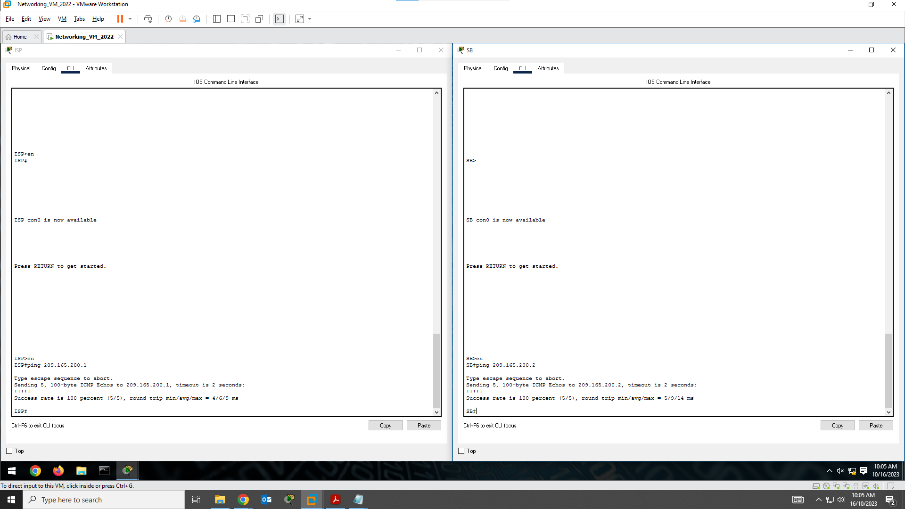

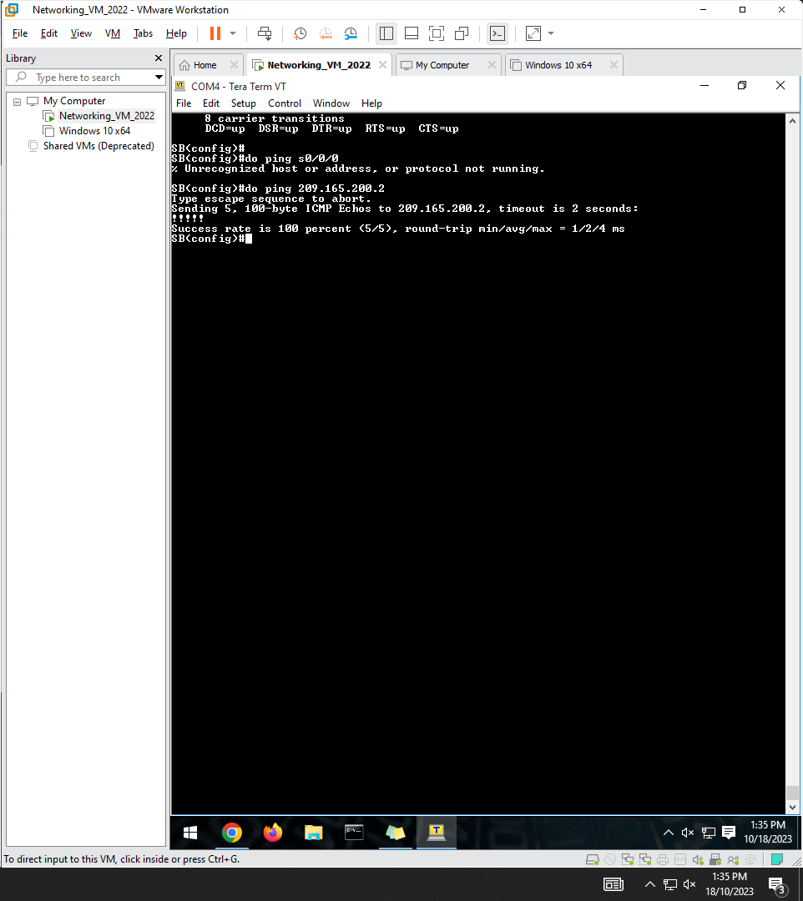

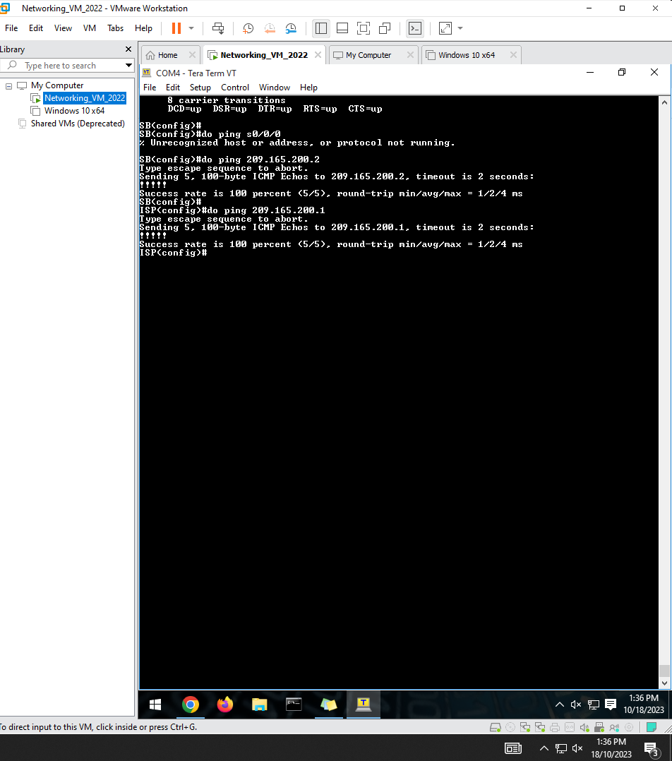

## Part 3: Configure HDLC between the ISP router and the MG Router

1. Display the serial interface’s encapsulation.

On the ISP and MG Router, issues **show interface serial** *interface-id* to display the current serial encapsulation. You will find the default serial encapsulation for a Cisco router is HDLC.

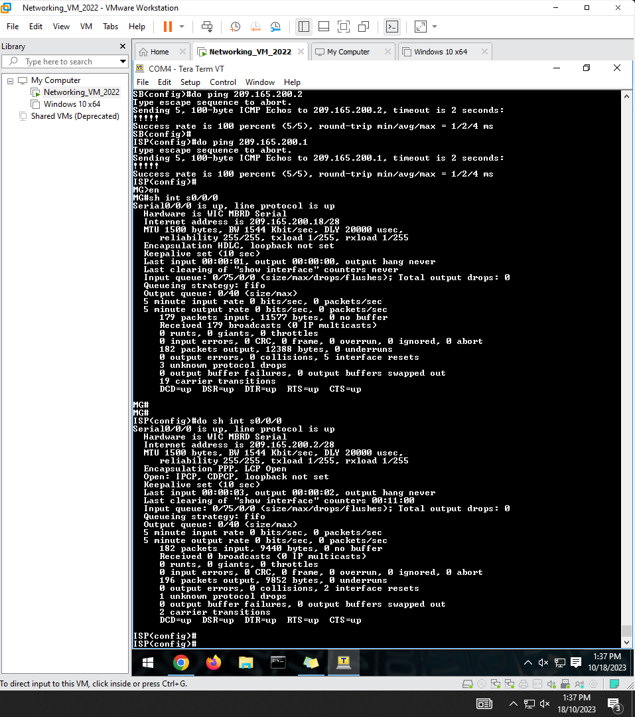

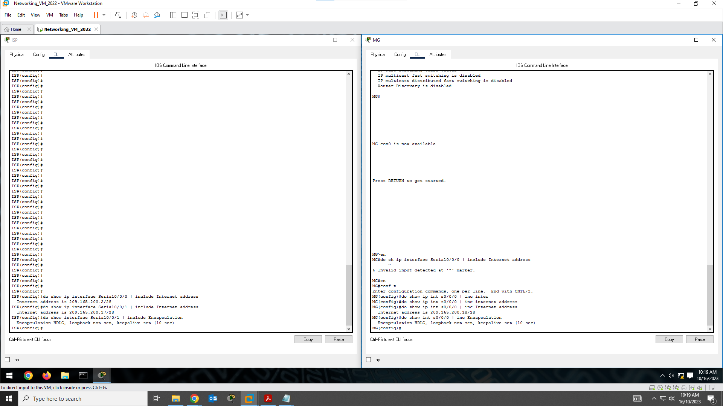

1. Verify the HDLC connection between the ISP router and MG Router.

Keep the current HDLC configuration and ping from the ISP to the MG Router’s S0/0/1 interface. The ping should be successful.

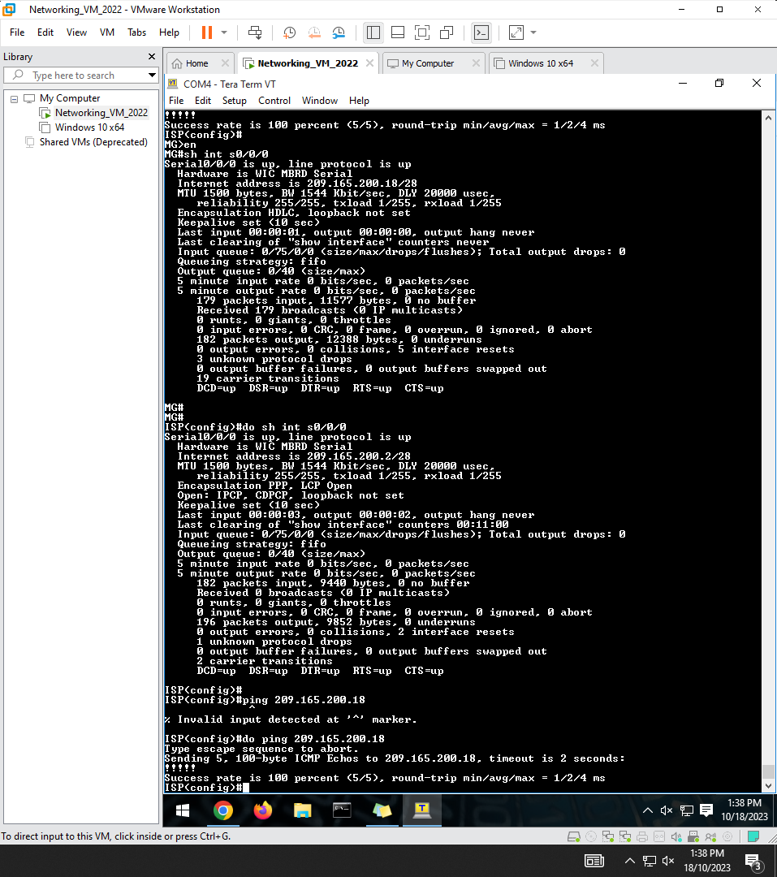

| ISP | MG |
| --- | --- |
| do show ip interface Serial0/0/1 | include Internet address  do show interface Serial0/0/1 | include Encapsulation | do show ip interface Serial0/0/0 | include Internet address  do show interface Serial0/0/0 | include Encapsulation |

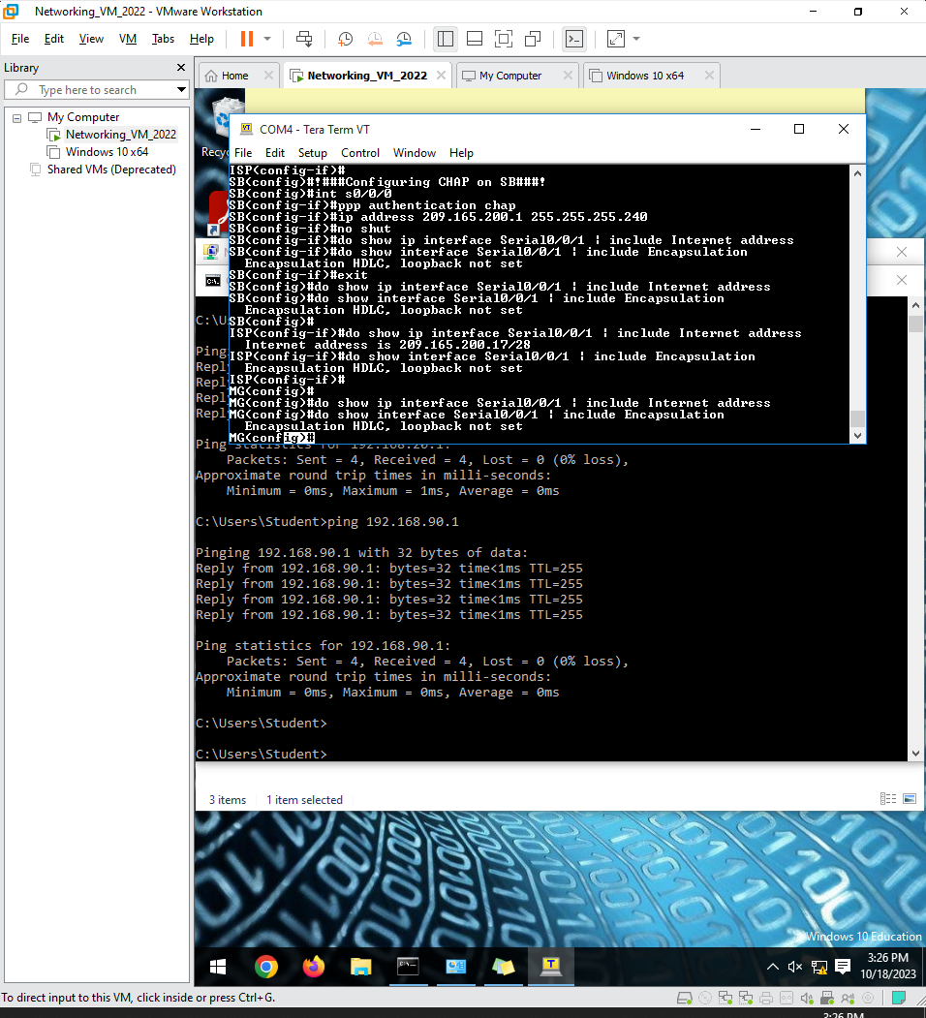

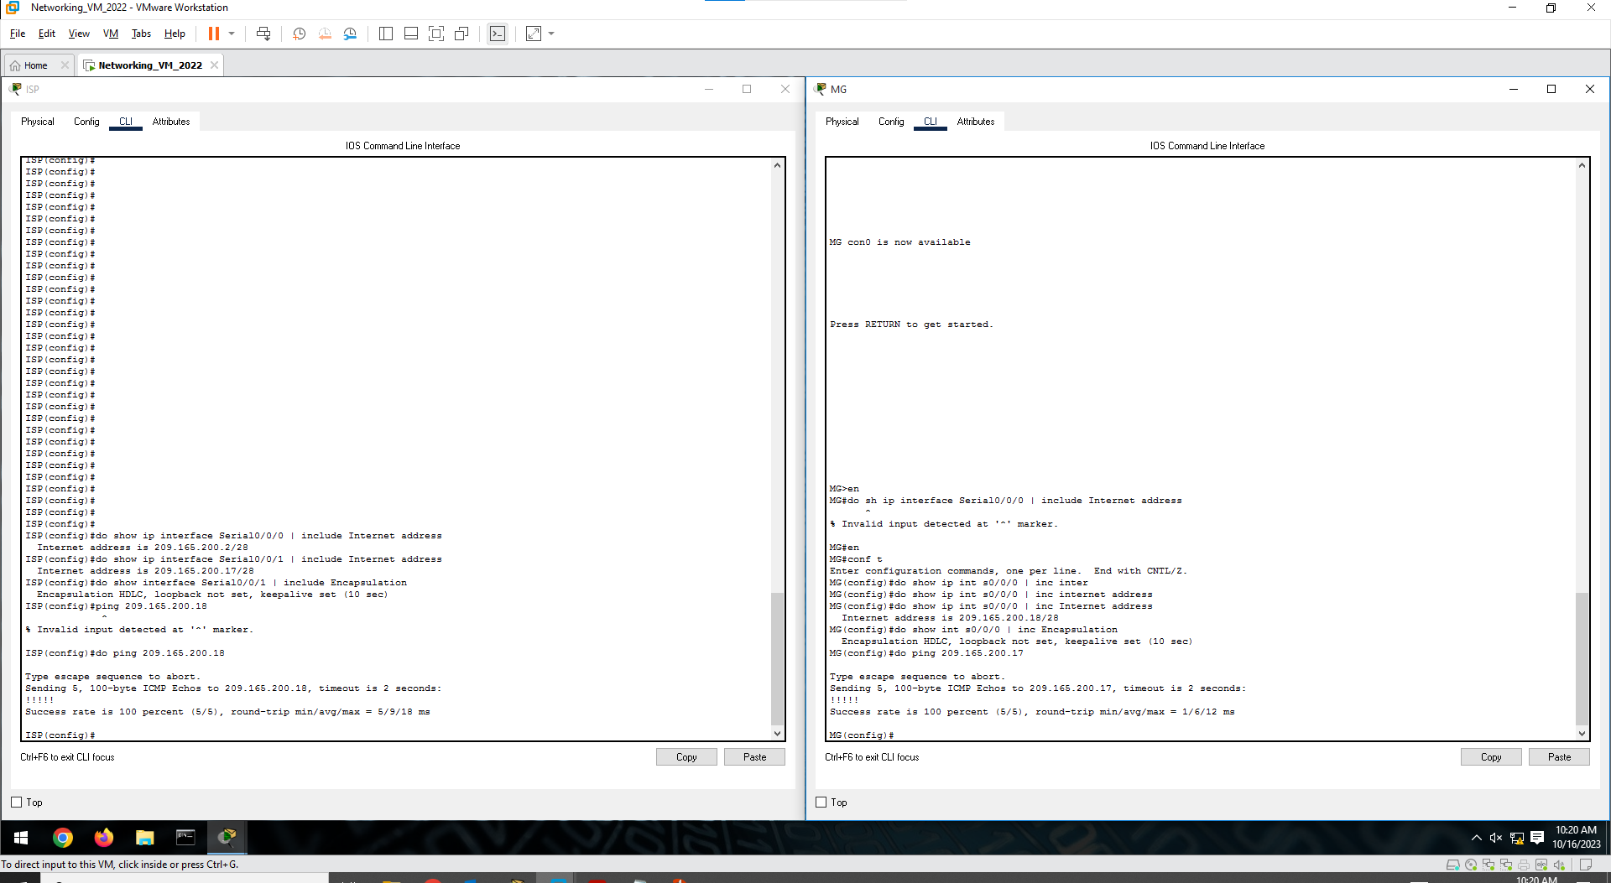

## Part 4: Configure OSPF

1. Configure OSPF on the SB Router, ISP, and MG Router with Process ID 1 in area 0. Note: Area 0 is the backbone area in OSPF which means area 0 is indispensable.

| SB | ISP | MG |
| --- | --- | --- |
| !###Enabling OSPF on SB Router!###!  en  conf t  router ospf 1  network 209.165.200.0 0.0.0.15 area 0  !###Broadcast all the Sub-networks of the roas in order to be discoverable by OSPF###!  network 192.168.20.0 0.0.0.63 area 0  network 192.168.30.0 0.0.0.63 area 0  network 192.168.90.0 0.0.0.7 area 0 | !###Enabling OSPF on ISP Router!###!  en  conf t  router ospf 1  network 209.165.200.0 0.0.0.31 area 0 | !###Enabling OSPF on MG Router!###!  en  conf t  router ospf 1  network 209.165.200.16 0.0.0.15 area 0  network 172.16.0.0 0.0.0.255 area 0 |

1. Verify the Connection.

You should be able to ping any devices from anywhere in the network.

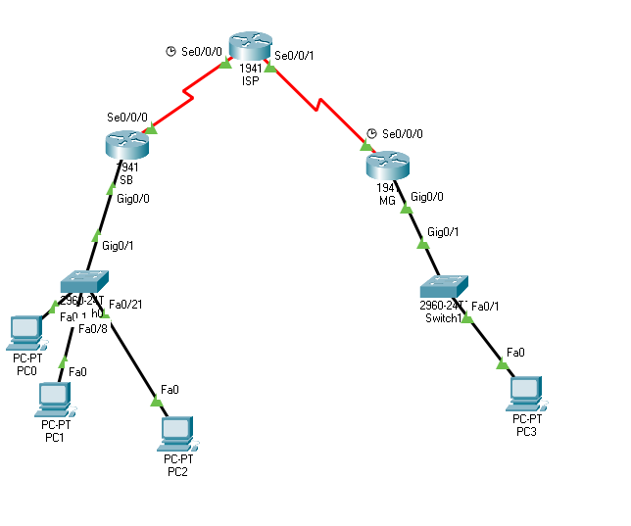All pings work successfully👍

## Part 5: Demonstration, Mark off, and Submission

1. Demonstrate the following to your instructor and ask for mark off:

* Show interface s0/0/0 on the SB Router to verify the serial encapsulation. Take a screenshot of the output and paste it to Part 2 template.

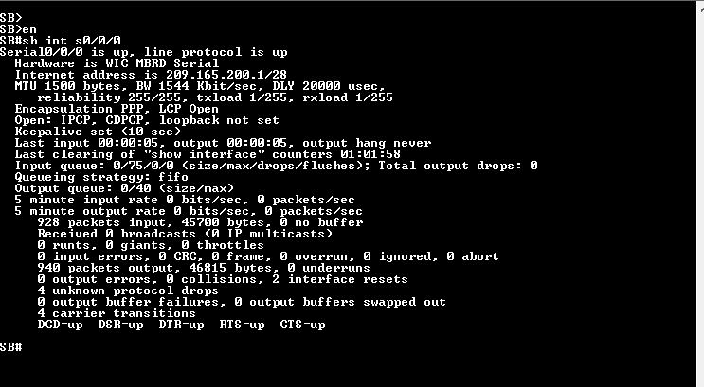

* Show run on the SB Router and take a screenshot of the commands that configure interface s0/0/0 as ppp encapsulation and ppp authentication to Part 2 template.

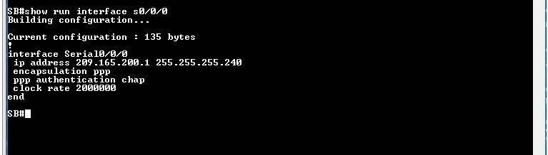

* Show ip route on the SB Router to verify the OSPF routing information. Take a screenshot and paste it to Part 2 template.

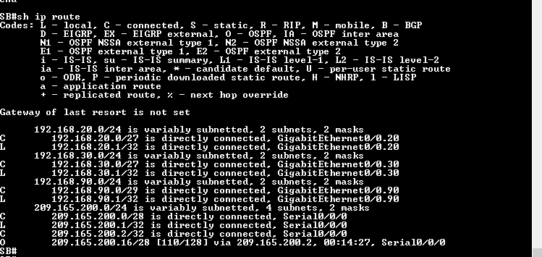

* Show run on the ISP to verify the PPP configuration.
* 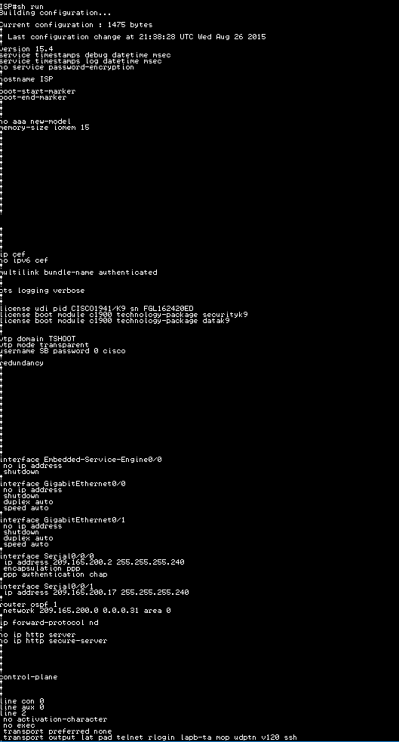
* 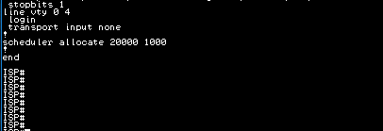
* MG-PC-1 can ping CS-PC-1, Marketing-PC-1, and DC-1.
* 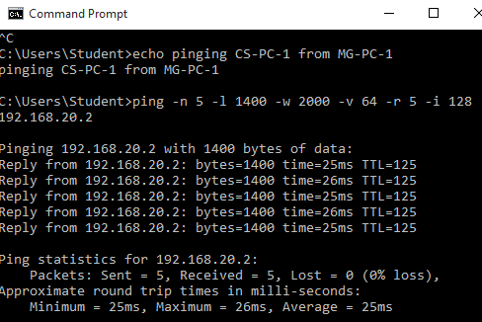
* 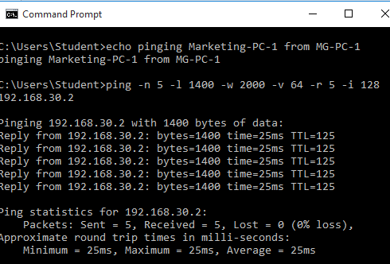

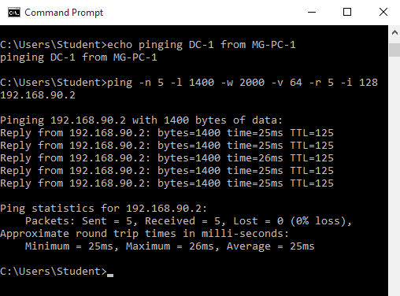

* MG-PC-1 can browse the web pages on CS-FS, and Marketing-FS.

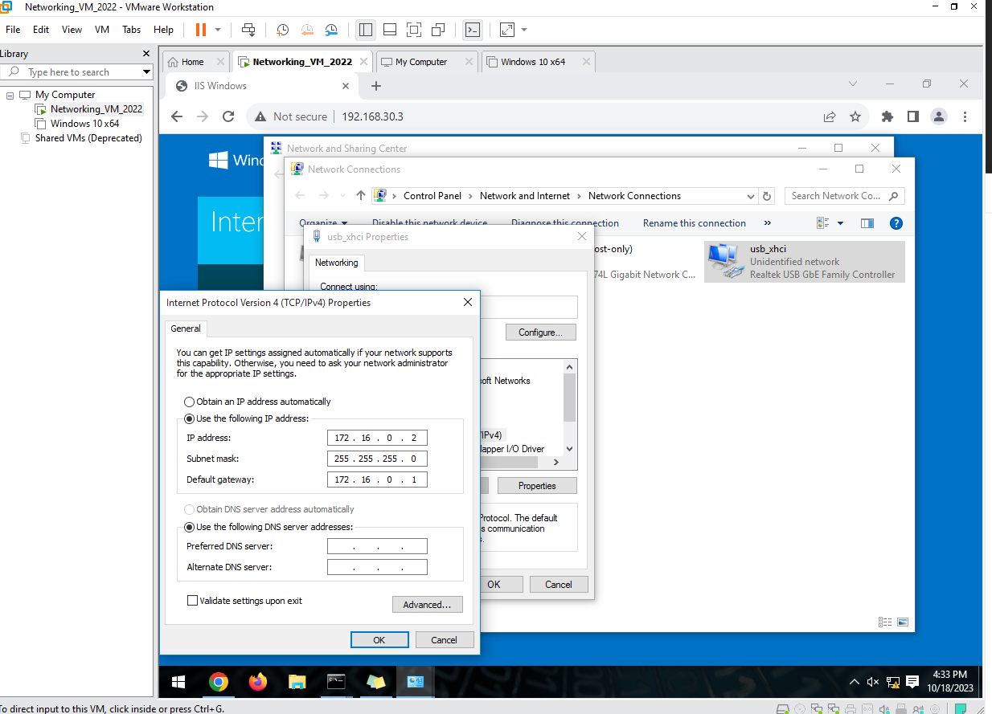

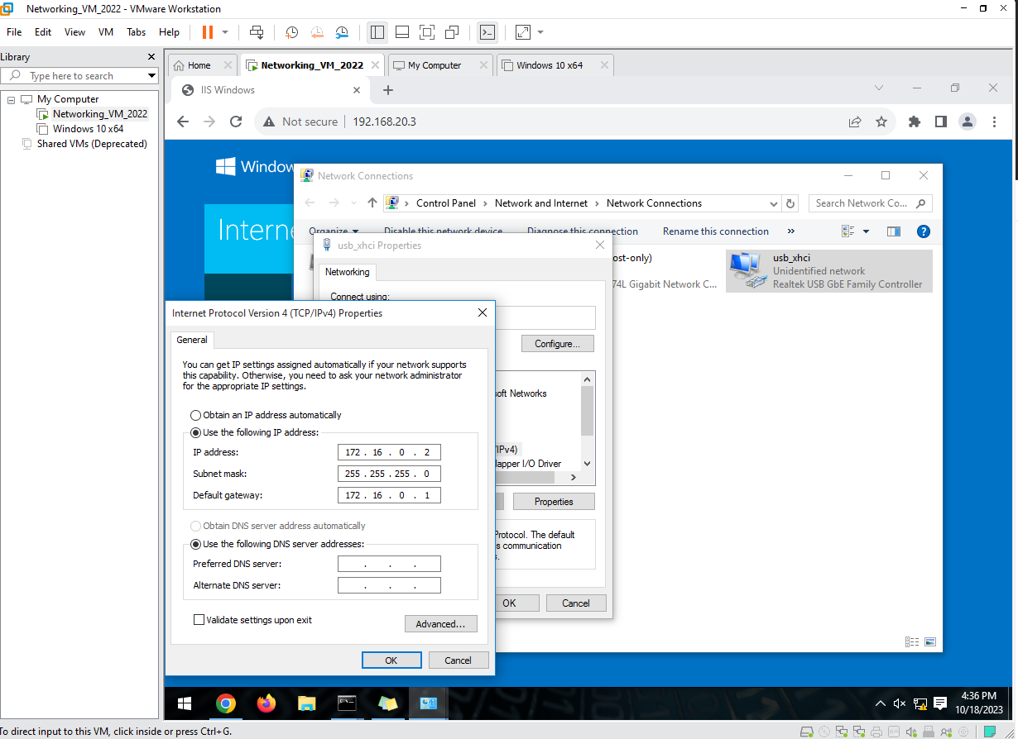

* CS-FS and Marketing-FS can browse the webpage on the DC-2.

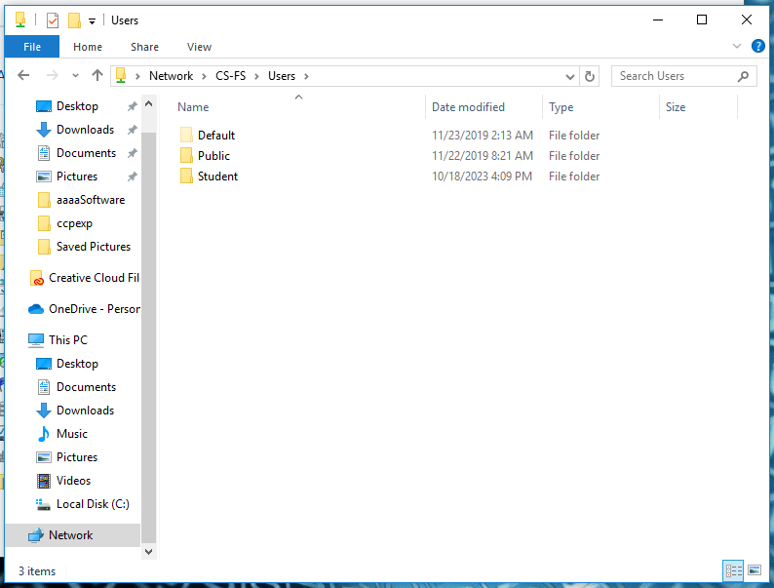

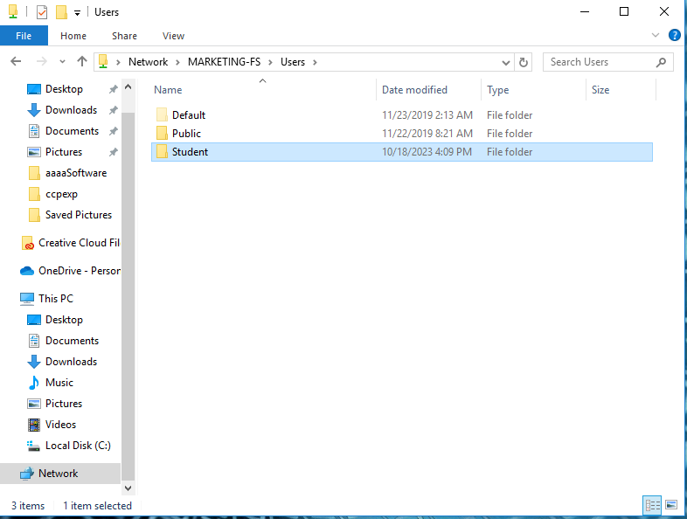

1. Backup the running-config on the routers and the swtiches.

* Backup all routers’ running-config in plain text files for the future practical labs.

[OSPF Part Lab 2 Configuration Files](https://drive.google.com/open?id=1uFK92NEkGtZaXkxTAjAigjVOuE2mjJOE)

* Backup SB-S1’s running-config and vlan.dat in plain text files for the future practical labs.

# Lab 2 Network Address Translation Instructions



| Device | Interface | IP Address/Prefix | Default Gateway |
| --- | --- | --- | --- |
| SB Router | S0/0/0 | 209.165.200.1/28 |  |
| ISP | S0/0/0 | 209.165.200.2/28 |  |
|  | S0/0/1 | 209.165.200.17/28 |  |
| MG Router | S0/0/1 | 209.165.200.18/28 |  |
|  | G0/1 | 172.16.0.1/24 |  |
| MG-PC-1 | Fastether port | 172.16.0.10/24 | 172.16.0.1/24 |
| DC-2 | Fastether port | 172.16.0.2/24 | 172.16.0.1/24 |

In this lab, you are going to configure NAT on the WAN link of the SB Router. OSPF is going to be removed from the SB router. ISP is symbolizing the internet side which is untrustful. SB router is going to hide the ip address details of its LAN from the internet.

## Part 1: Setup the network environment as in Activity 3

**Step 1**. Cable the network as the topology above.

| Packet Tracer | IRL |
| --- | --- |
|  |  |

**Note**: In each subnet, the PC and the Server can be running as VMs on a same physical host.

**Step 2**. Import the backup running-config files from Task 2 to the network devices.

**Step 3**. Import the backup vlan.dat from Task 2 into SB-S1.

**Step 4**. Configure the end devices IP address as in Task 2.

| PC1 | PC2 | PC3 | PC4 |
| --- | --- | --- | --- |
|  |  |  |  |

**Step 5**. Remove OSPF settings from the SB Router.

| SB |
| --- |
| !### Removing OSPF Settings from the SB Router!##!  en  conf t  router ospf 1  no network 209.165.200.0 0.0.0.15 area 0  !###Disabling all the sub-networks of SB's ROAS so its not discoverable by OSPF###!  no network 192.168.20.0 0.0.0.63 area 0  no network 192.168.30.0 0.0.0.63 area 0  no network 192.168.90.0 0.0.0.7 area 0  exit |

**Step 6**. Configure a default route on the SB Router towards the ISP router.

| SB |
| --- |
| SB  !### Configuring a default route towards the ISP Router!##!  en  conf t  !###The next-hop IP address of the ISP router on the connecting interface is 209.165.200.2###!  ip route 0.0.0.0 0.0.0.0 209.165.200.2  exit |

**Step 7**. Verify the network connection. SB Router should be able to ping any other devices.

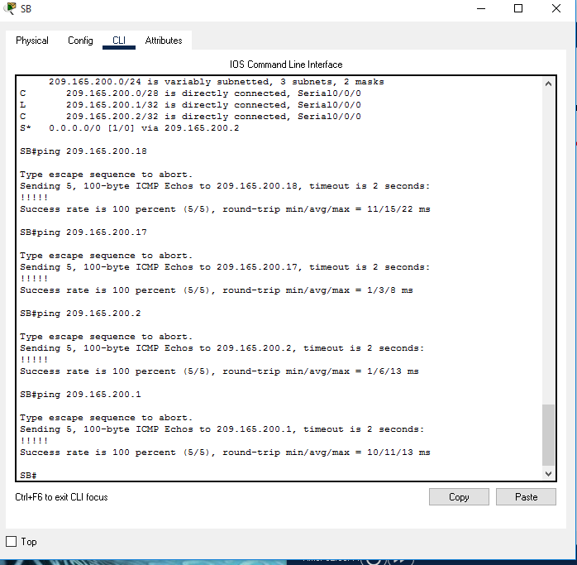

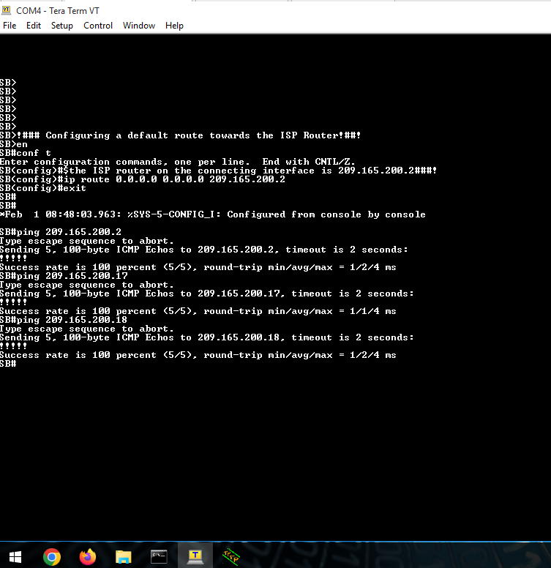

## Part 2: Configure and verify PAT on SB Router

**Step 1**. Define an access control list that matches the SB Router’s LAN private IP address range.

| SB |
| --- |
| !###Step 1. Define an access control list that matches the SB Router’s LAN private IP address range.###!  !###Defining ACL on SB Router  en  conf t  access-list 1 permit 192.168.20.0 0.0.0.31  access-list 1 permit 192.168.30.0 0.0.0.31  access-list 1 permit 192.168.90.0 0.0.0.31  exit |

**Step 2**. Define the PAT from the inside source list to the serial interface s0/0/0 on the SB Router.

| SB |
| --- |
| !###Step 2. Define the PAT from the inside source list to the serial interface s0/0/0 on the SB Router.###!  conf t  ip nat inside source list 1 int s0/0/0  exit |

**Step 3**. Specify the **sub-interfaces** and serial interfaces as nat inside/outside on the SB Router.

| SB |
| --- |
| !###Step 3. Specify the sub-interfaces and serial interfaces as nat inside/outside on the SB Router.###!  en  conf t  !### Specifying Serial interface on SB->ISP Router to be outside###!  int s0/0/0  ip nat outside  no shut  exit  !###Specifying the sub-interfaces as inside###!  !###############################################!  !###Setting g0/0.20 as inside for translation###!  int g0/0.20  ip nat inside  no shut  exit  !###Setting g0/0.30 as inside for translation###!  int g0/0.30  ip nat inside  no shut  exit  !###Setting g0/0.90 as inside for translation###!  int g0/0.90  ip nat inside  no shut  exit  !Verifying PAT Config was successfull...  do sh ip nat trans |

**Step 4**. Verify the network connections.

* Pings from CS-PC-1 to MG-PC-1 should be successful.
* Pings from Marketing-PC-1 to MG-PC-1 should be successful.
* Pings from DC-1 to MG-PC-1 should be successful.
* Pings from MG-PC-1 or DC-2 to any end devices on the SB Router’s LAN should be unsuccessful.
* Show ip nat translations on the SB Router should display all the network address translation information.

## Part 3: Configure and verify Static NAT on Access Router

**Step 1**. Configure a static mapping to translate between the WWW Server private ip address and the public address 209.165.200.10.

| SB |
| --- |
| !###Step 1. Configure a static mapping to translate between the WWW Server  !and private ip address and the public address 209.165.200.10.###!  en  conf t  !###Configuring static NAT translation for WWW server###!  ip nat inside source static 192.168.90.3 209.165.200.10  end  !### verify that NAT translation works###!  sh ip nat trans |

A static map is configured to tell the SB Router to translate the WWW Server’s private ip address into an external public address 209.165.200.10. This allows a user from the Internet to access the WWW Server.

**Step 2**. Test the configuration.

* Display the static NAT table by issuing the **show ip nat translations** command on the SB Router.
* 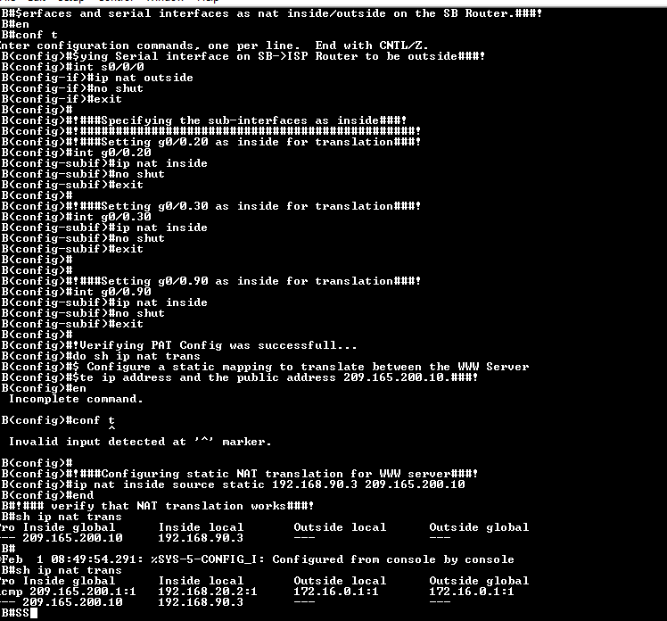  
  (ISSUE above attachment showed it still worked this was due to OSPF still running on SB)

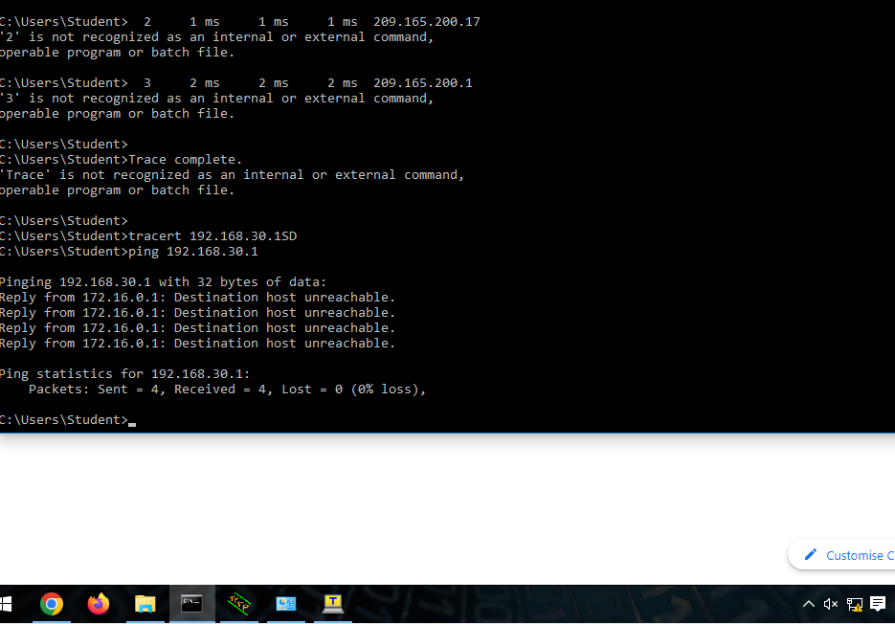

* From MG-PC-1, ping the WWW Server’s external ip address 209.165.200.10. The ping should be successful.
* 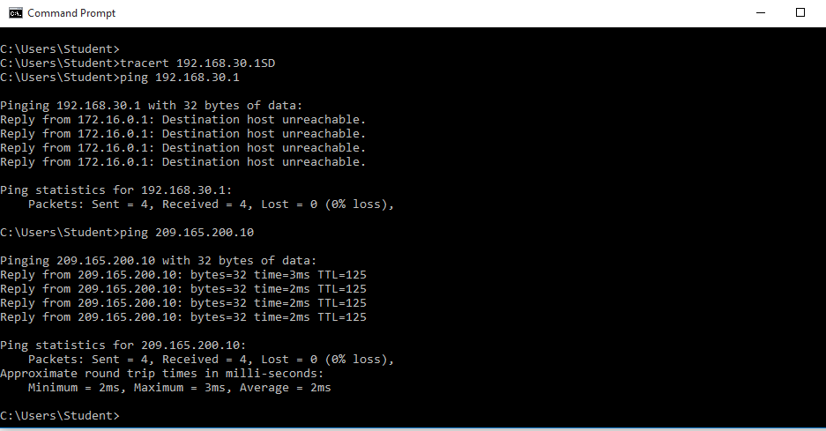
* 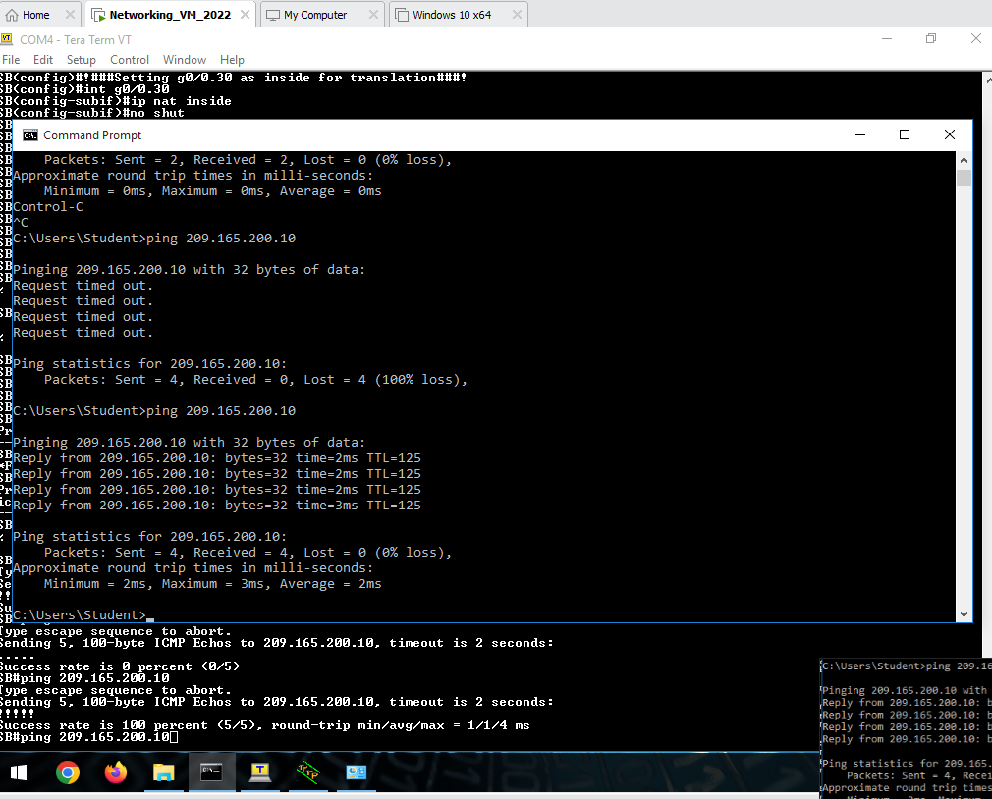

## Part 4: Demonstration, Mark off, and Submission

1. Demonstrate the following to your instructor and ask for mark off:

* From MG-PC-1 or DC-2, pings to any end devices on the SB Router’s LAN should be unsuccessful.

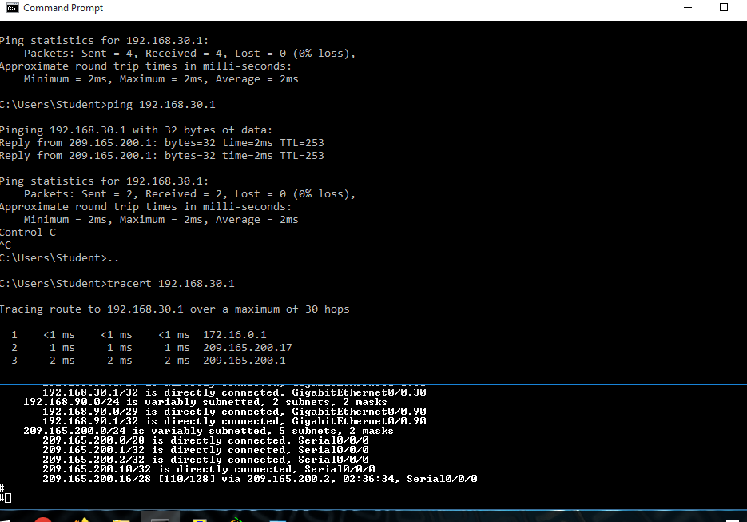

* From the CS-PC-1, ping the MG-PC-1 should be unsuccessful.
* From the Marketing-PC-1, ping the MG-PC-1 should be unsuccessful.
* From the WWW, ping the MG-PC-1 should be unsuccessful.
* From the MG-PC-1, ping the WWW Server’s external IP 209.165.200.10 should be successful.
* 
* From the MG-PC-1, browse the WWW Server’s web page using its external IP 209.165.200.10 should be successful.
* 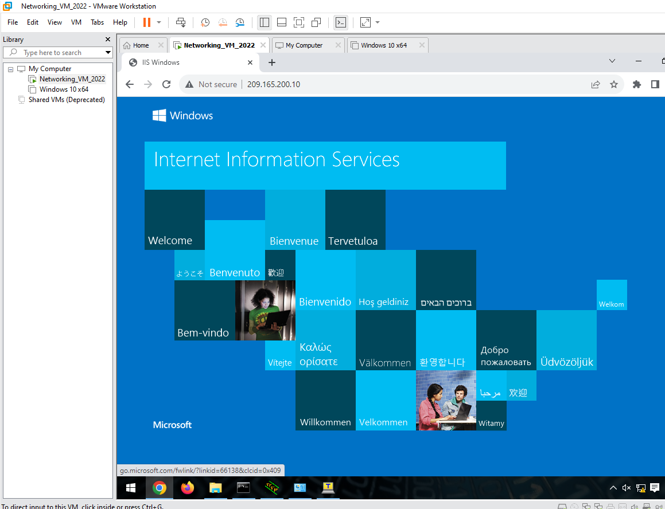
* Display the NAT table by issuing the **show ip nat translations** command on the SB
* 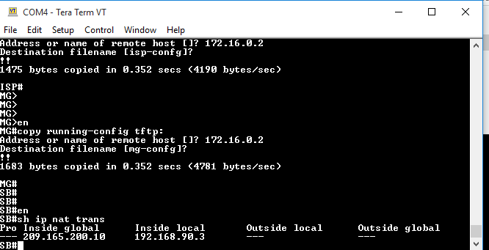Router. Take a screenshot and paste it to Part 2 template.

1. Backup the running-config on the Access Router.

* Backup the SB Router’s running-config in plain text files for the future practical labs.
* Backup the ISP’s running-config in plain text files for the future practical labs.
* Backup the MG Router’s running-config in plain text files for the future practical labs.
* Backup the SB-S1’s running-config and SB-S1’s VLAN.dat into plain text files for the future practical labs.
* FINAL CONFIGS BELOW

<https://drive.google.com/drive/folders/1oeoTqnSerY60fiuzvCQ57jLMVat0ZiPe?usp=share_link>